Creating validation

We want to add a rule validation check. This can be done for many reasons a very simplistic example is if a customer is moving from a legacy system to an SAP system if they want to add a new material but still retain their old material number. Initially they can do this and possibly forget about the old material number as there is no validation. We can add a validation check to ensure anytime a material is created that the user will be prompted to input their old material number.

*Locate Validation rules page*

i) In SAP easy Access search IMGMDG

ii) Open General settings à Data Quality and Search à Validations and Enrichments then click on Validation and Derivation rules (follow Highlighted blocks below)

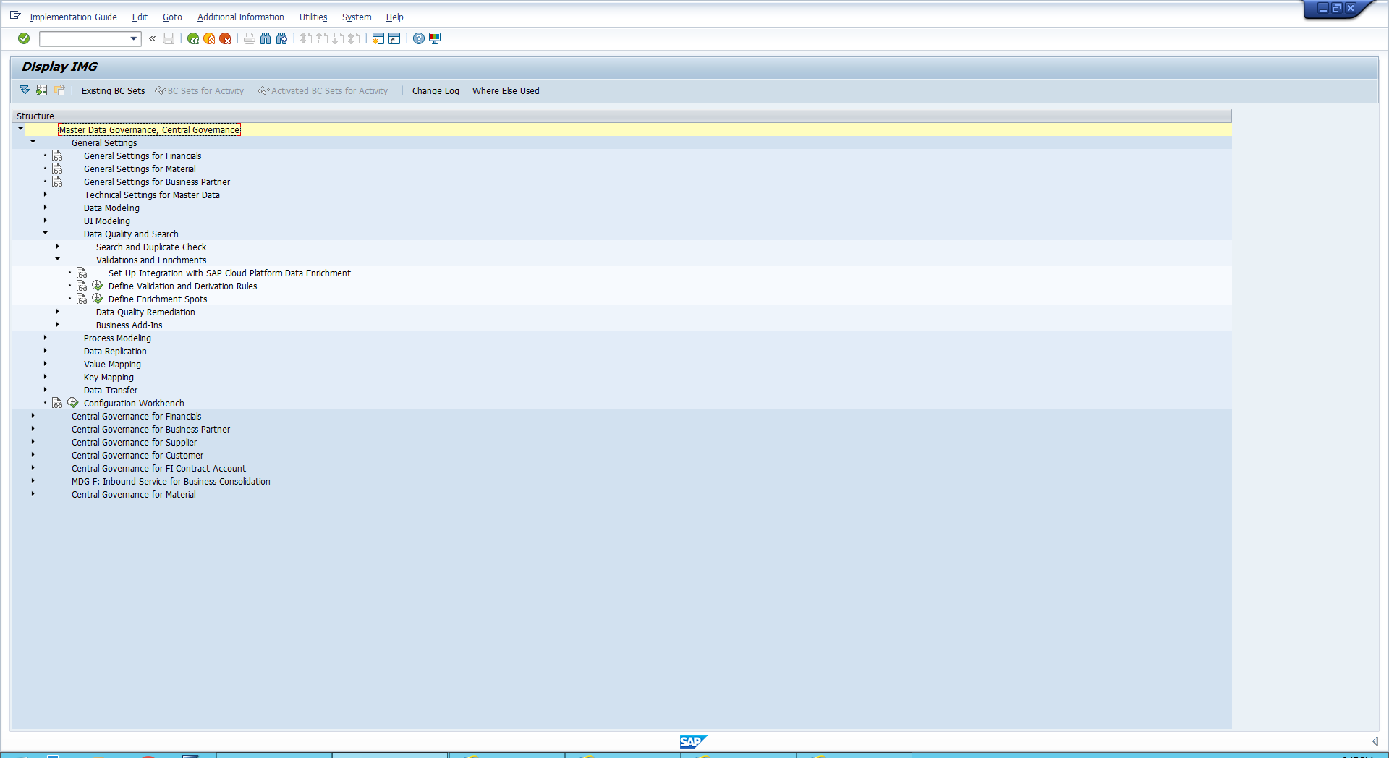

*A simpler way to find this is by inputting transaction code : usmd_rule*

iii) Enter MM into data model and click continue. If prompted click local object

*Business rule Framework*

i) Open Data Object you will see the framework. The list is all the fields from The MM model we opened

ii)Open Trigger Function à check entity.

*Check entity is used for Validation*

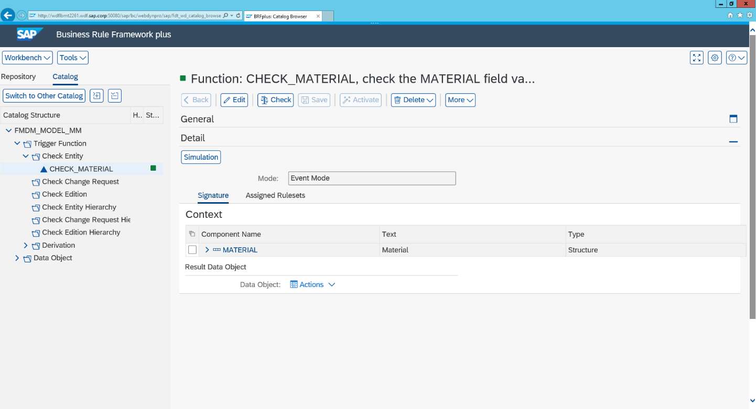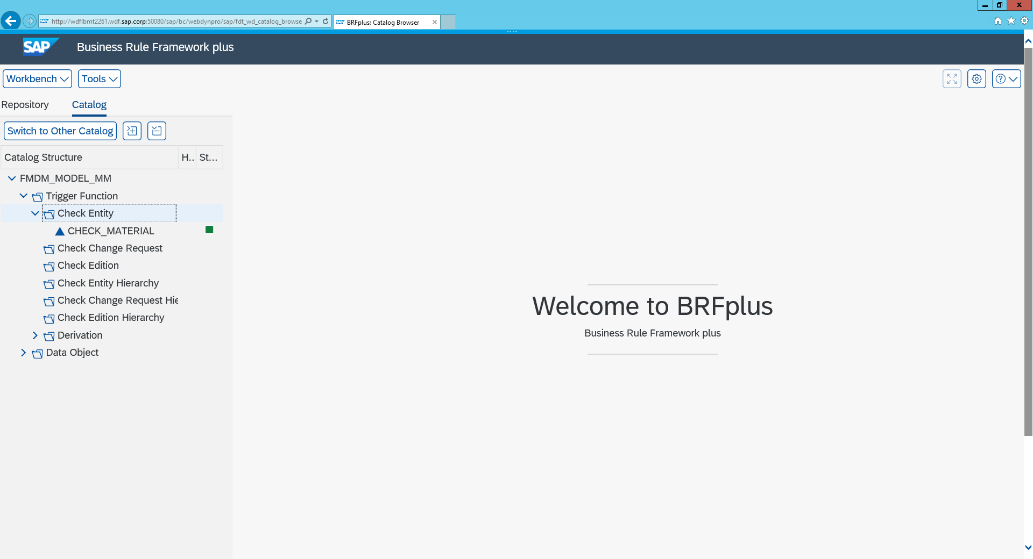

*The naming functions must follow : Check_material eg: RS_BISMT & RS_MATKL are other examples of the naming convention method*

iii) Open Assigned Rulesets _-> click edit and then à create RuleSet

iv) Enter the following:

*name: RS_BISMT*

*Short text: Validate Old MN*

*Text: Validating that old material number is filled*

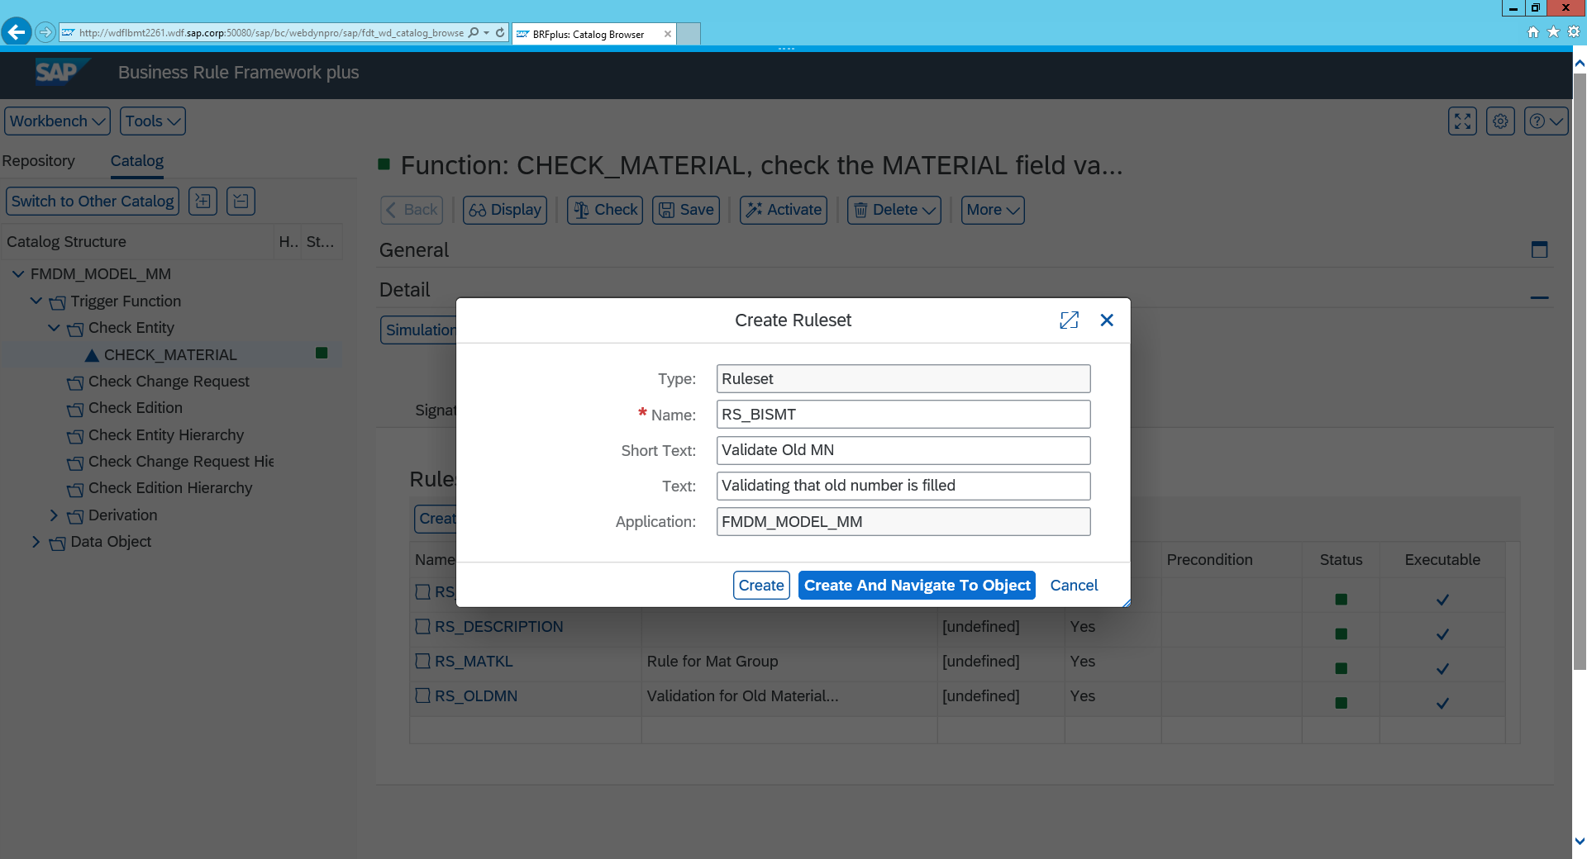

*V) Click create and navigate to object*

*Creating a rule*

*You will now be presented with Your RuleSet screen*

i) Click Insert Rule à create

*Here you can choose select either if you have previous rules created you would like to use but in our case we will create a new rule*

ii) click on Assign Condition à Use Value Range from .. à Default Objects à Current User

*This is essentially saying the rule validation will only apply to a specific user. Usually this is not something we would do with a customer but possibly could be done for Dates or time constraint projects.*

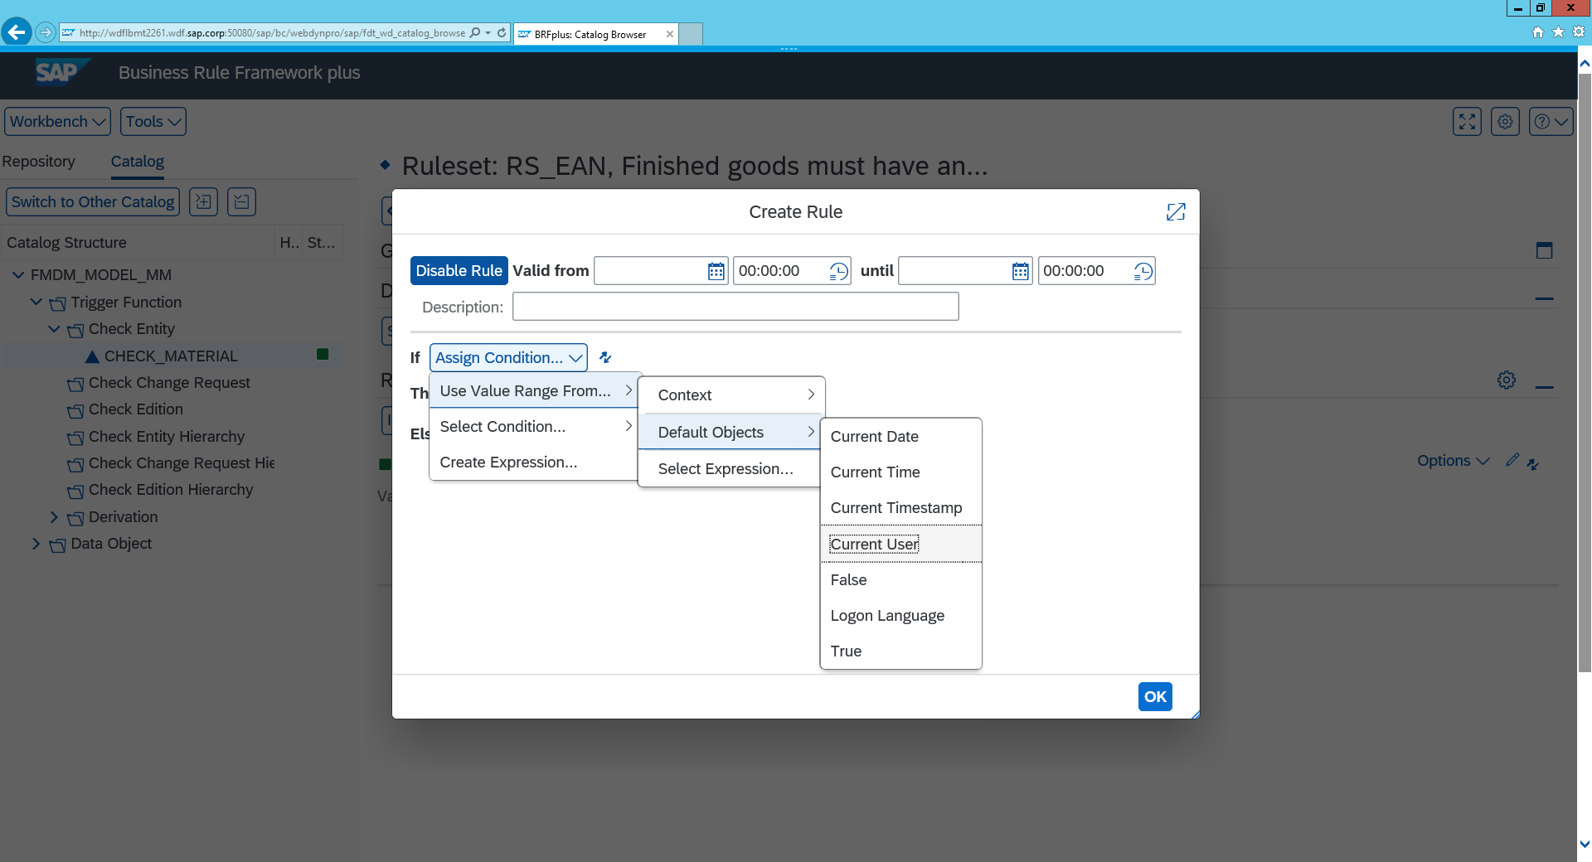

iii) Input your user number so the current user is equal to you

iv) Click change Condition à add conditions and then Change the operand to AND so you can ensure the condition is applied to your user

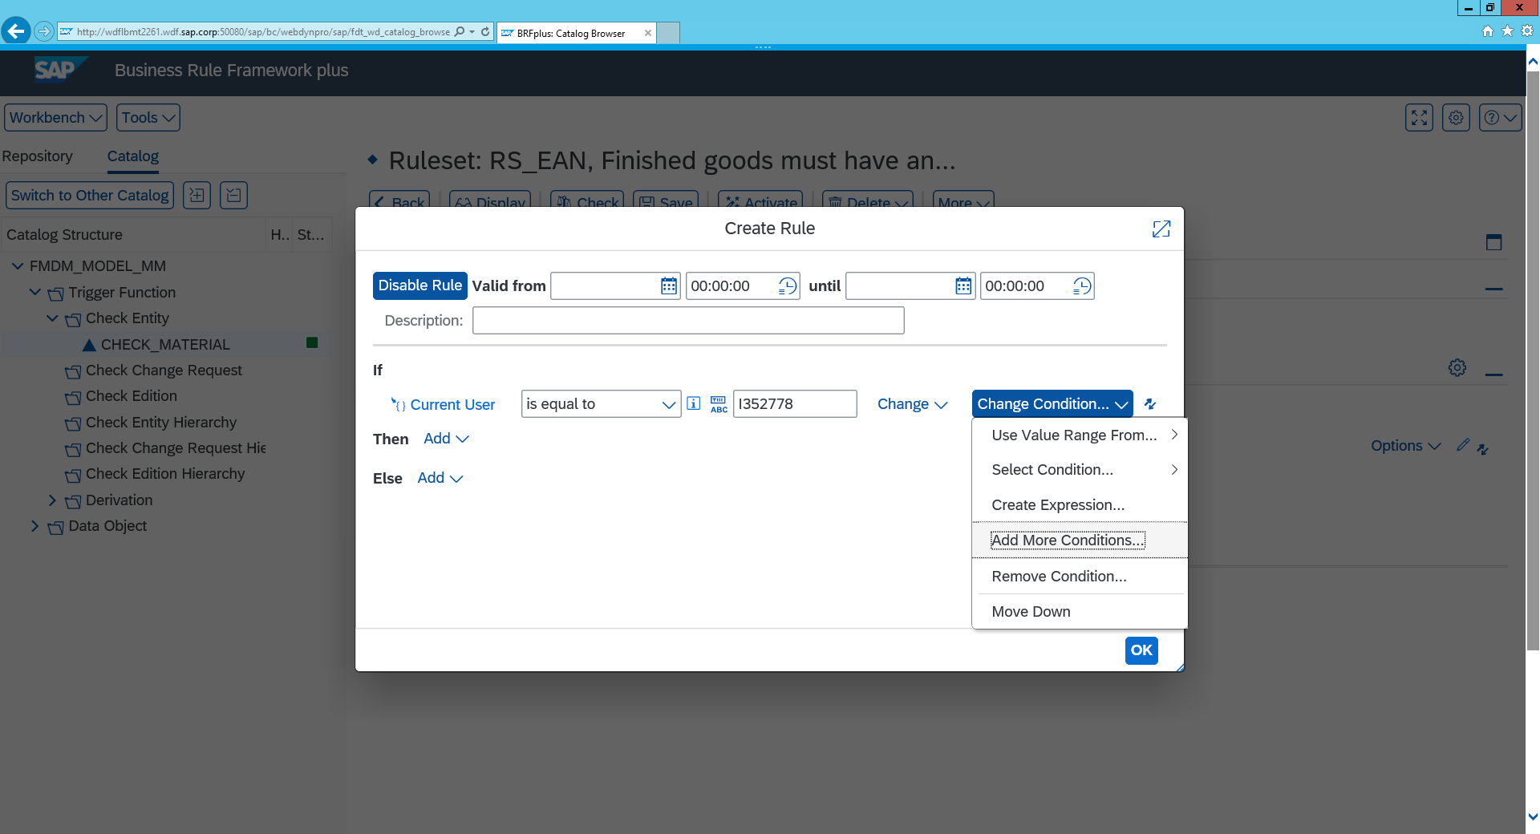

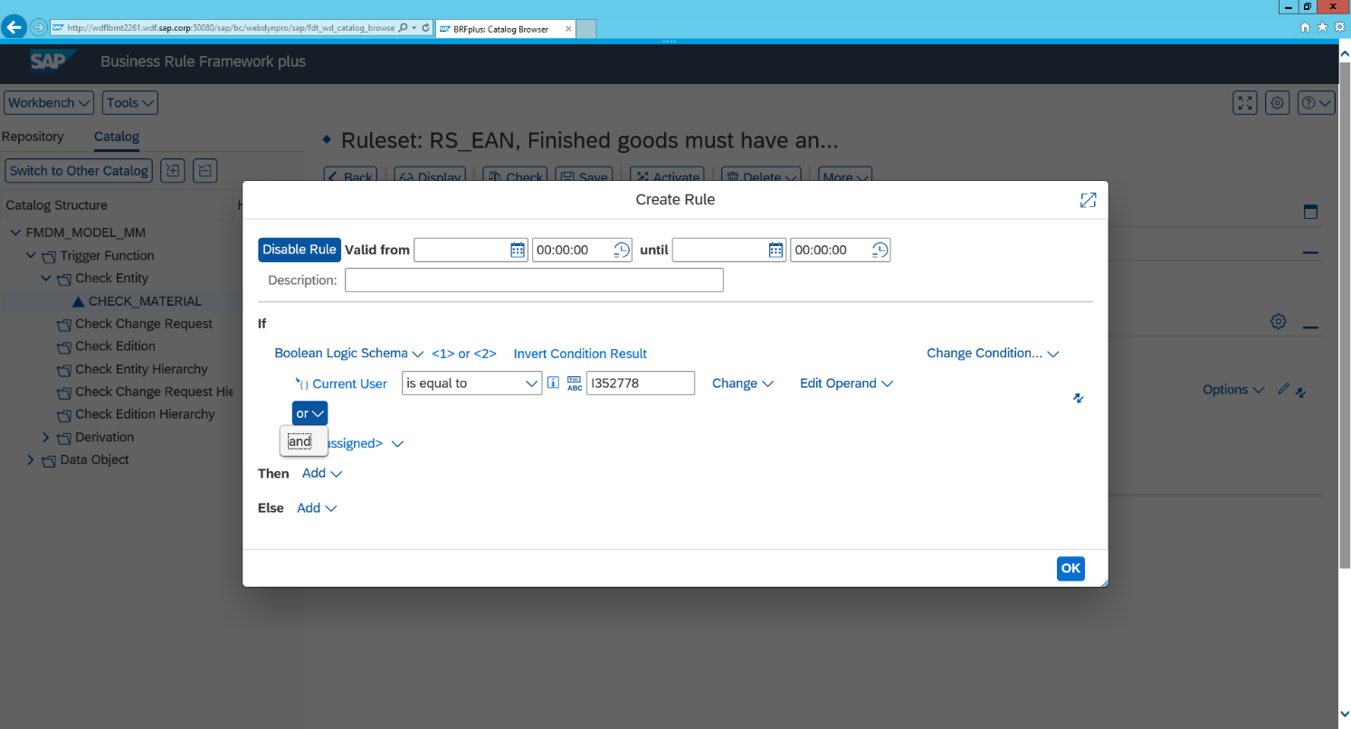

V) Assign Condition à Use Value Range from .. à context à old material number

Vi) change “is equal to” to “is initial” this checks if it is blank

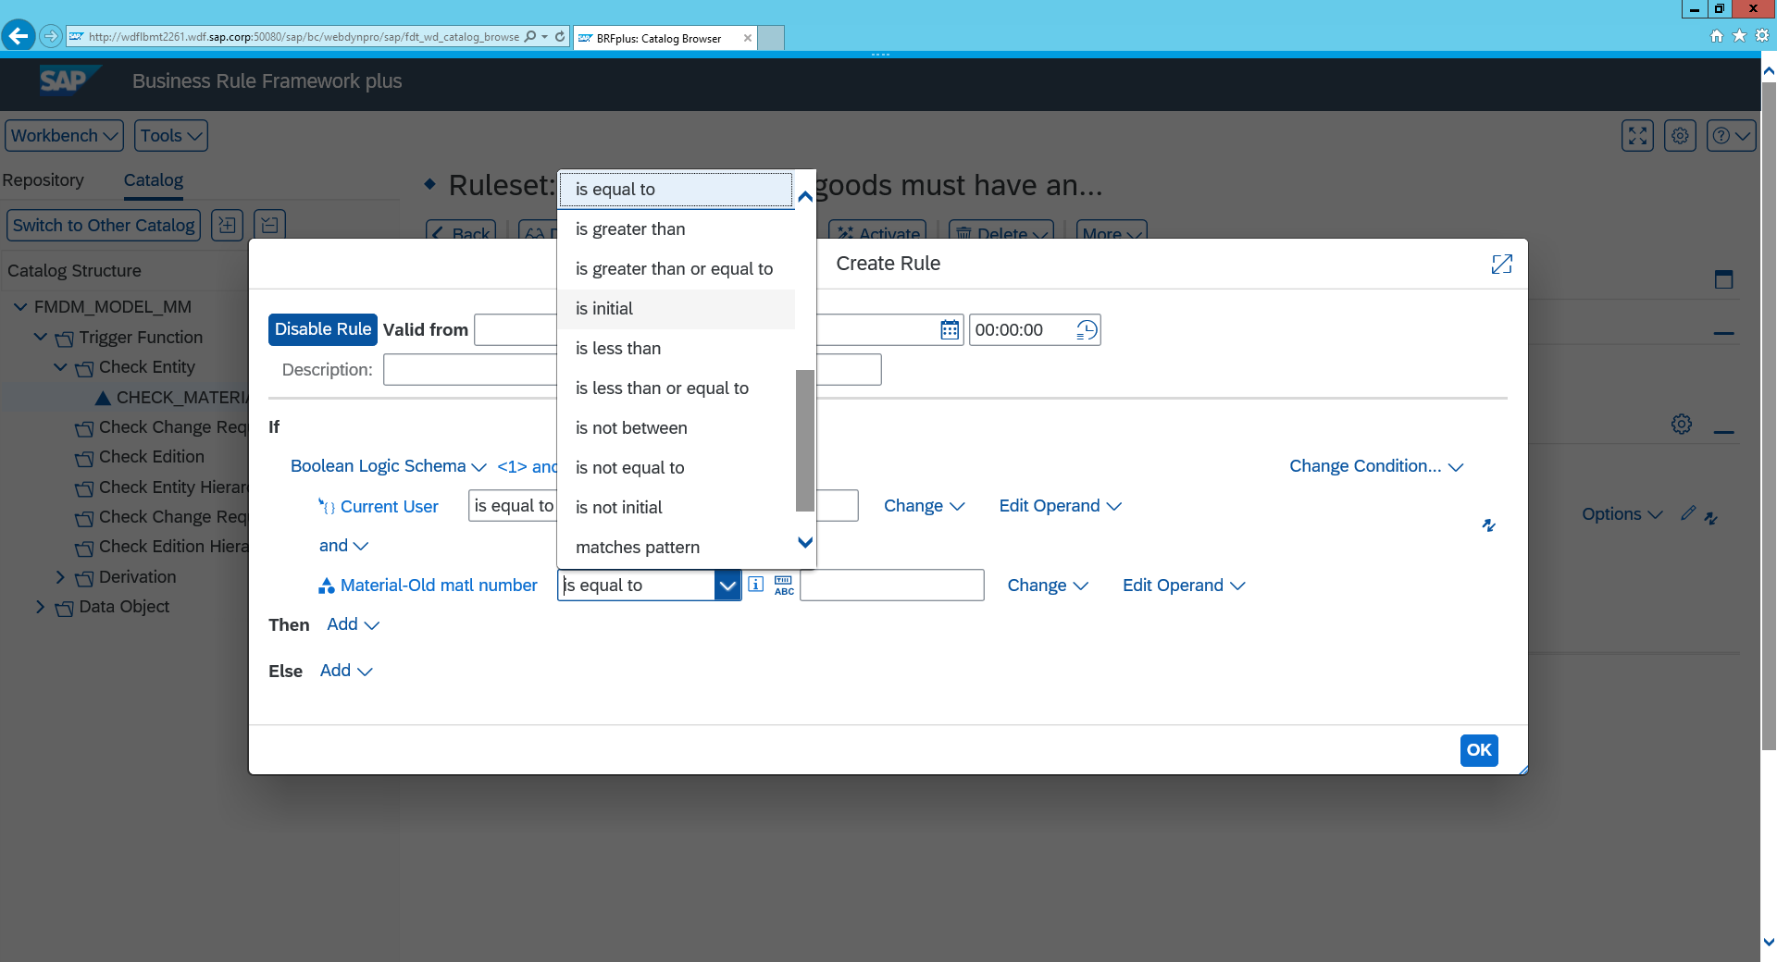

*If this condition matches we must then input what happens for eg: If Old material number is blank then we must give a warning or error*

Vii) Click Add à Perform Action à Create

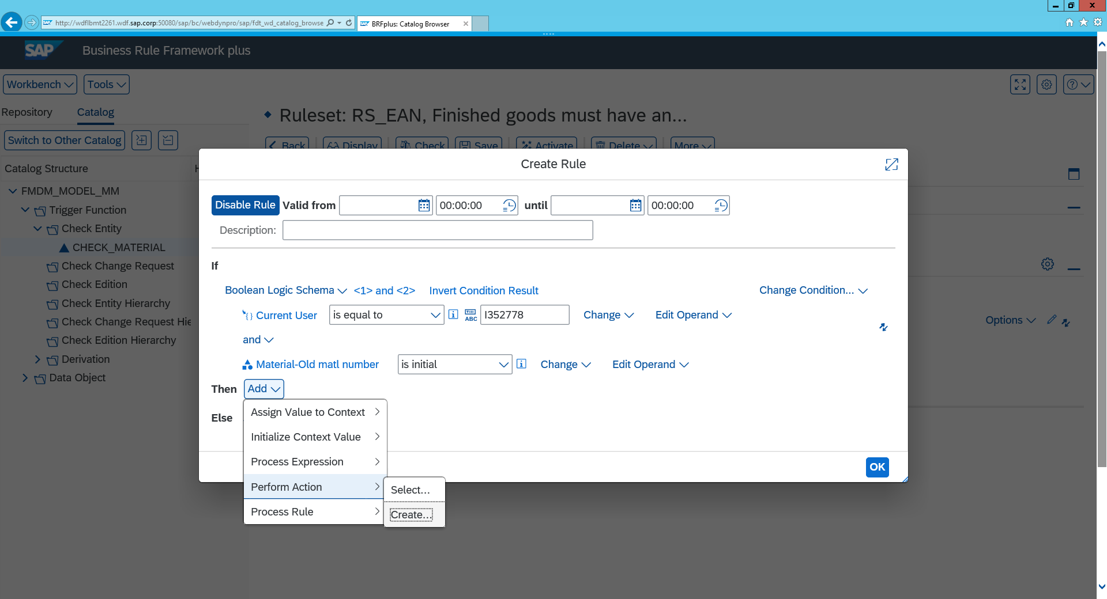c

Viii) Type choose Log Message (action)

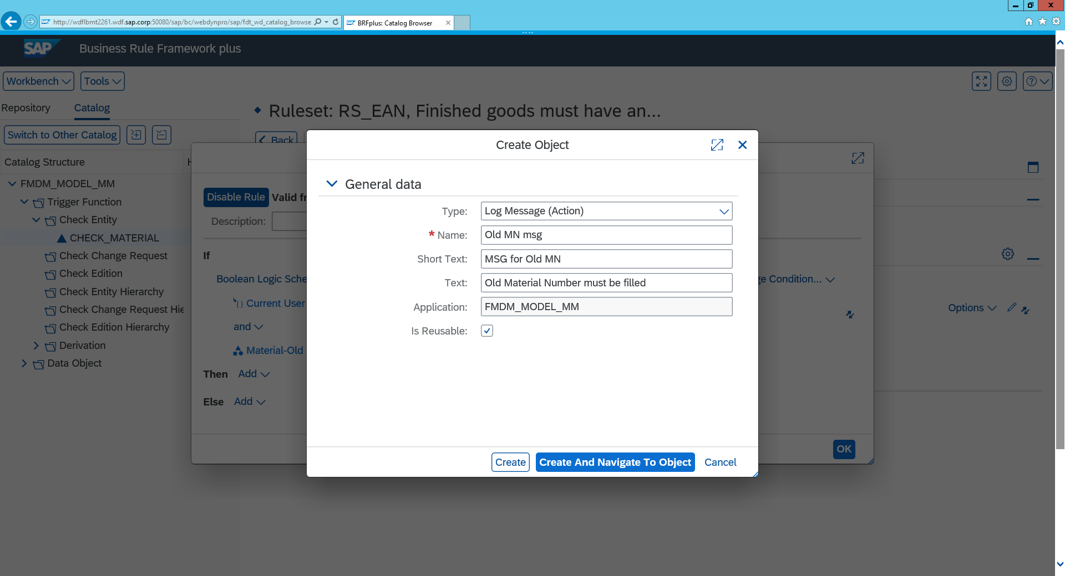

Viiii) Click create then okay and activate the rule à click yes when prompted

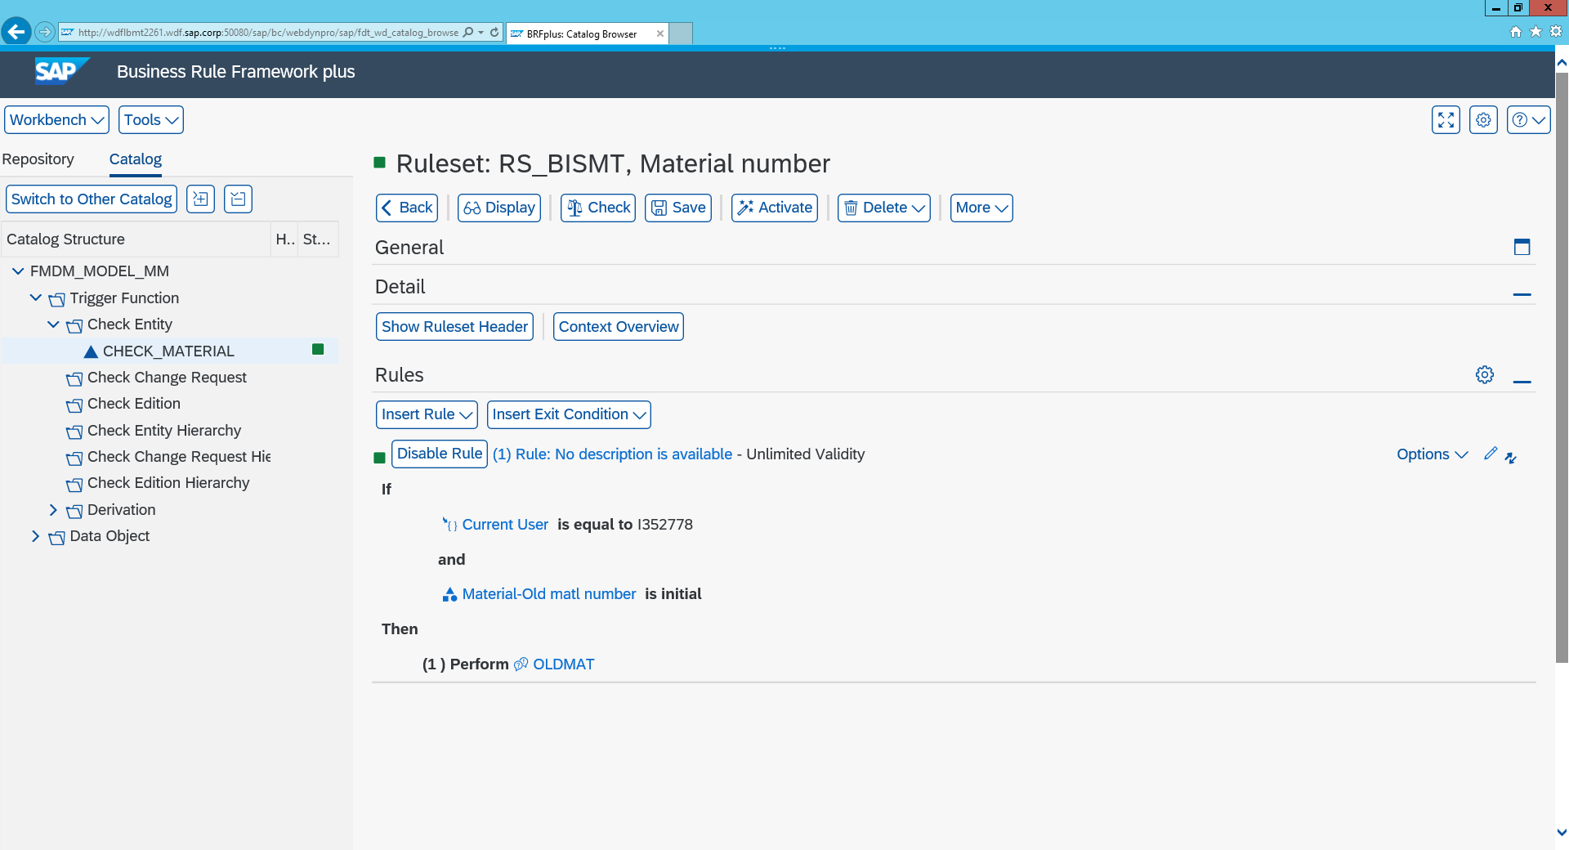

If we want to add in rules/validations based on change requests it is required that we add in an additional entity in signature for this

*Adding a signature*

Go back to the signature screen à Click “Add Existing Data Object

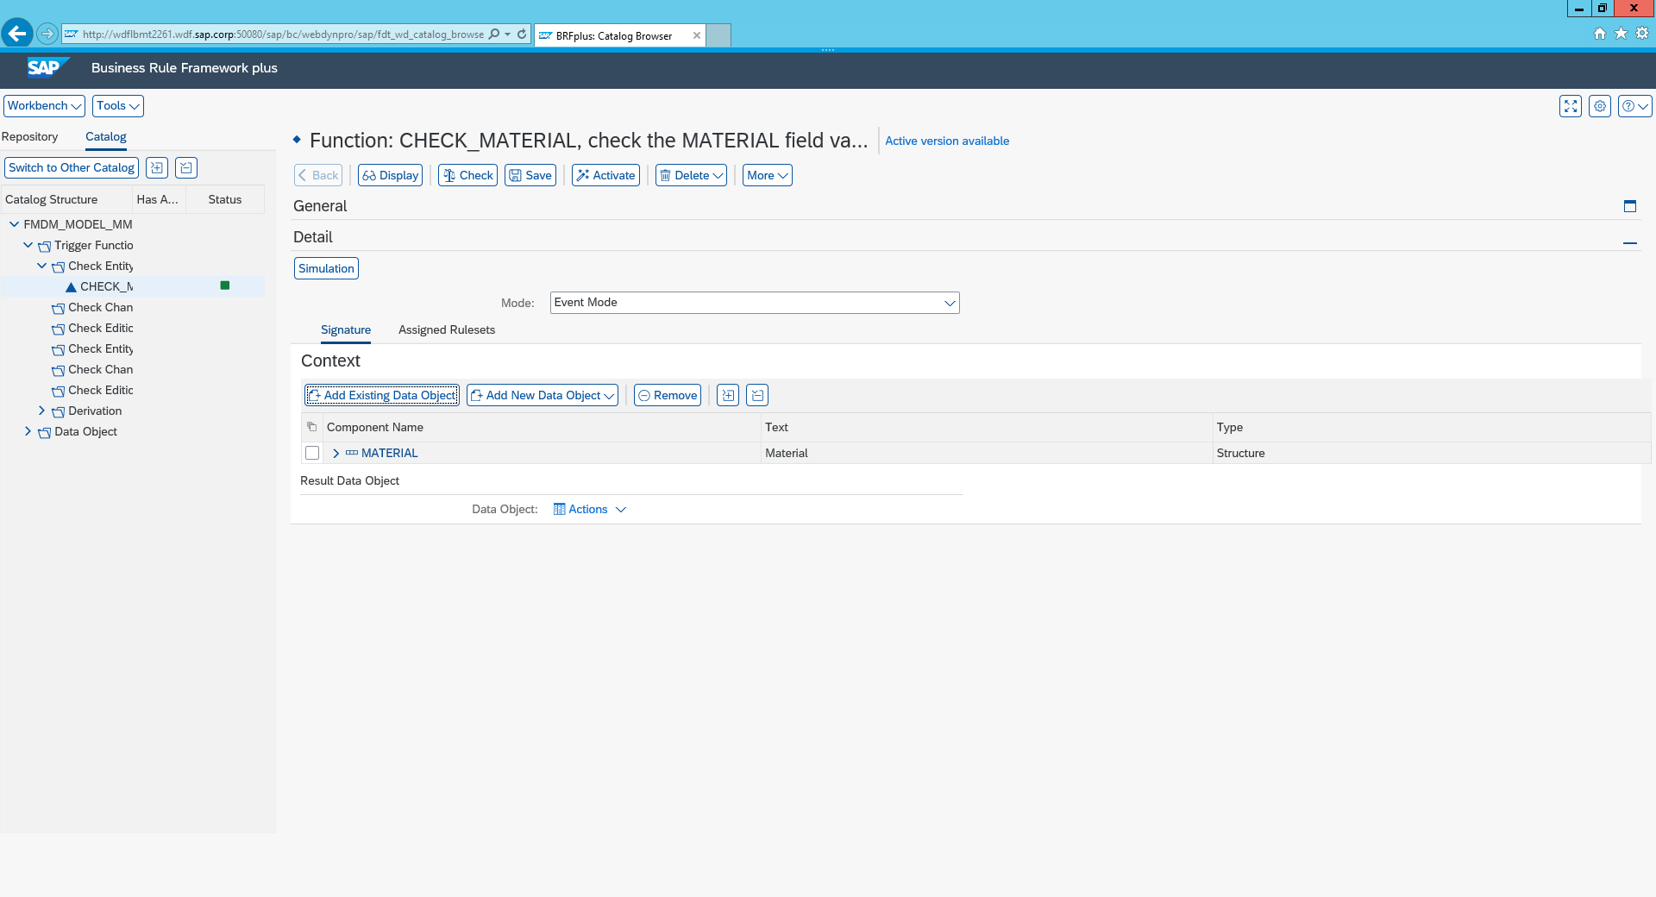

ii) Search: SAP*

iii) Click both step & Type of Chg. Request à Click ok à Save

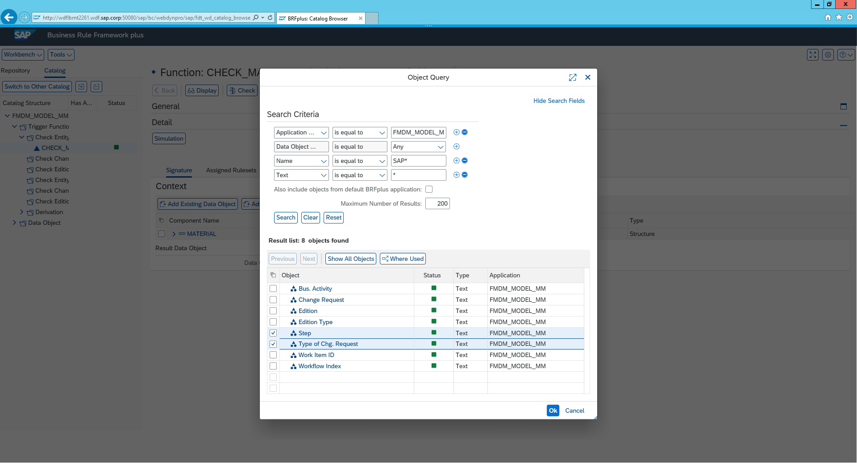

You can now add in rules and validations based on Change request Type and change request step.

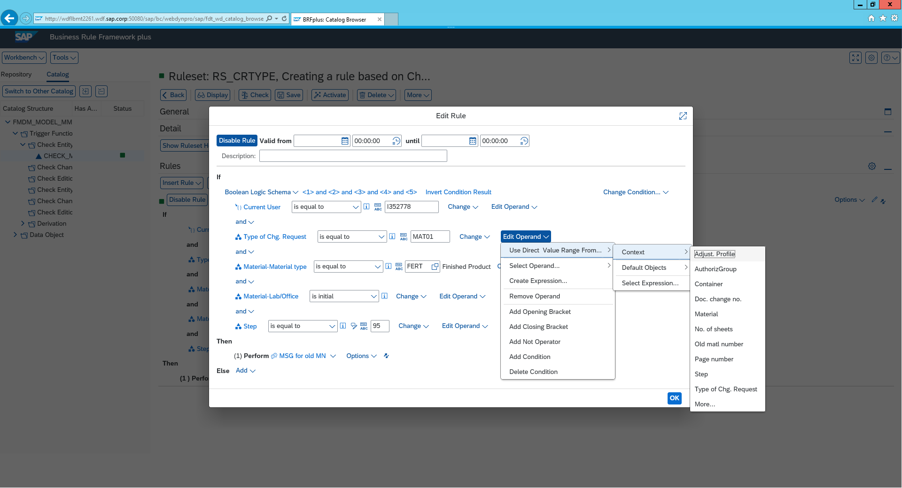

**Create a Validation for Finished Goods that must have an EAN Number**

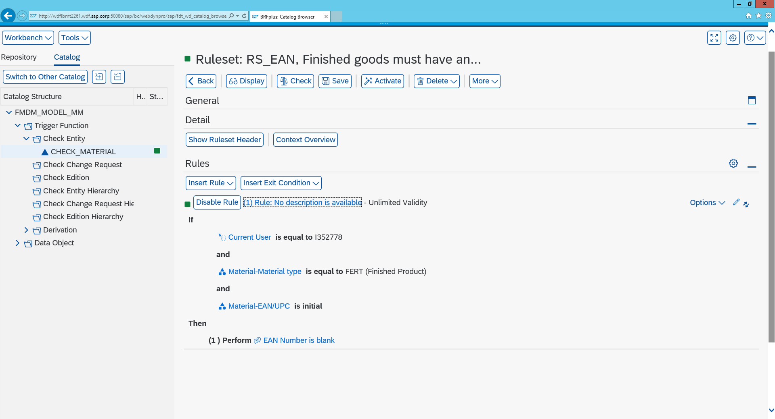

Result:

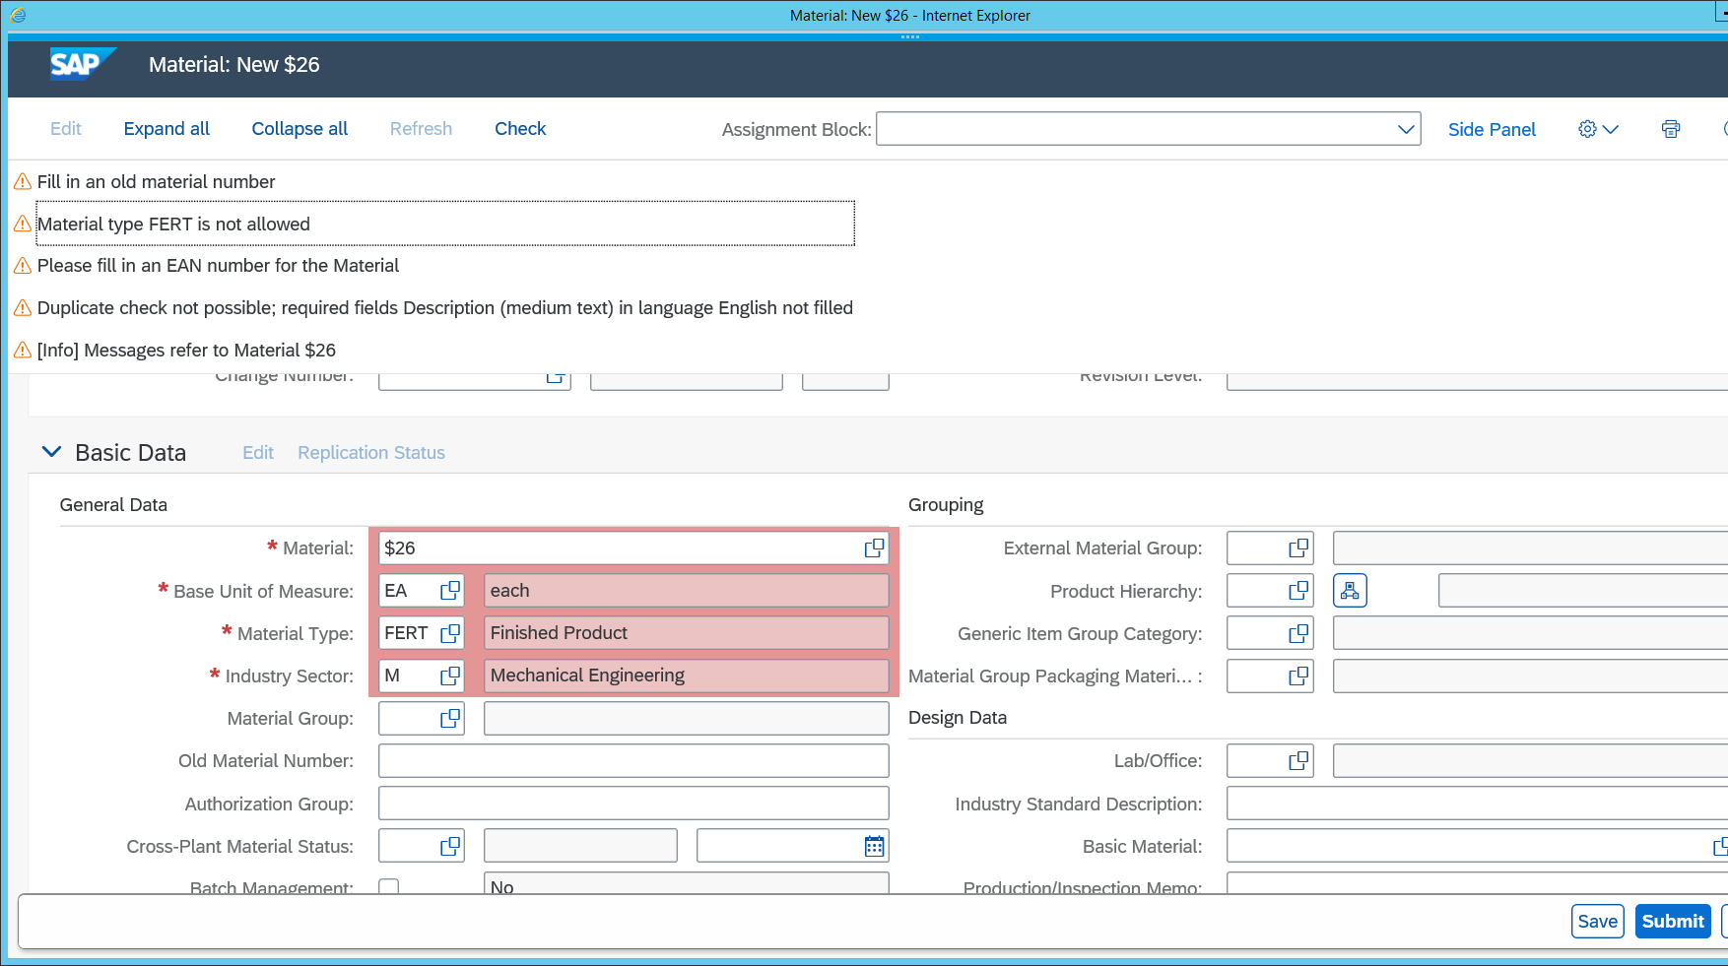

**Create a Validation for Raw material Goods when changed must have Laboratory field  value present.**

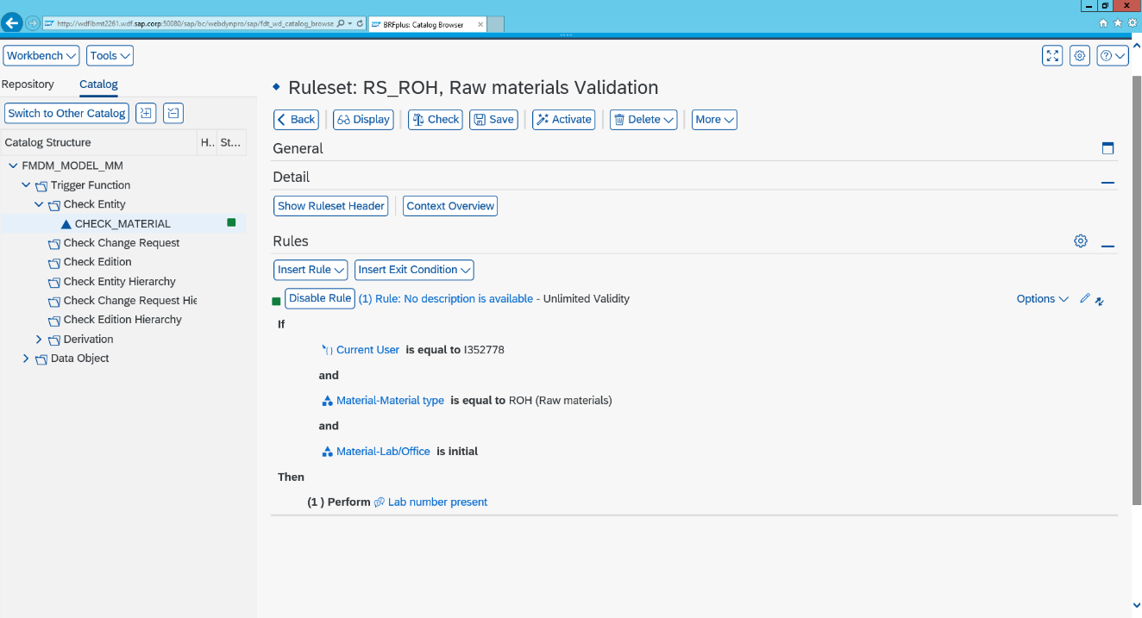

Result

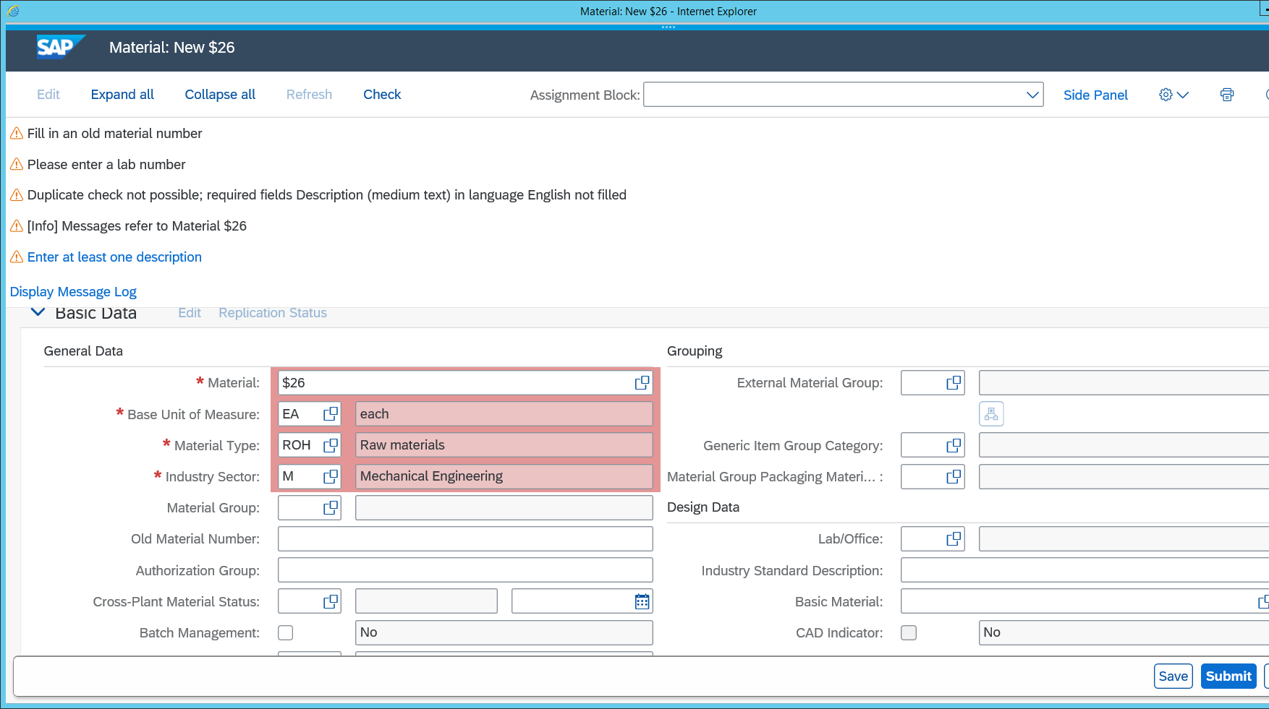

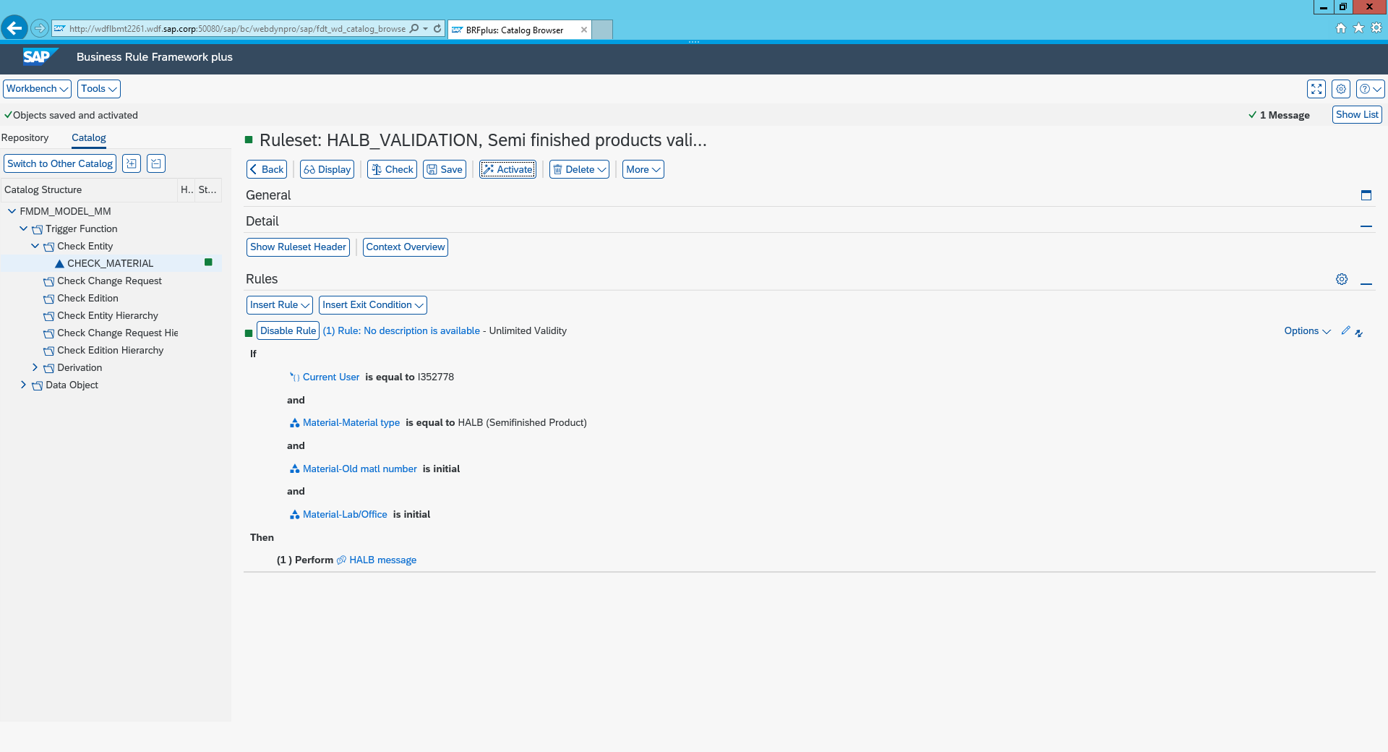

1. Create a Validation for Finished Goods that must have an EAN Number.
2. Create a Validation for Raw material Goods when changed must have Laboratory field value present.
3. Create a Validation where Old Material number and Laboratory is present for Semi Finished Goods.
4. Try a Validation where Finished Goods can be saved without a Plant but cannot be activated without a Plant!

